UNIT I INTRODUCTION TO Al AND PRODUCTION SYSTEMS Introduction to AI-Problem formulation, Problem Definition -Production systems, Control strategies, Search strategies. Problem characteristics, Production system characteristics -Specialized production system- Problem solving methods - Problem graphs, Matching, Indexing and Heuristic functions -Hill Climbing-Depth first and Breath first, Constraints satisfaction - Related algorithms, Measure of performance and analysis of search algorithms.
Introduction to AI:
  - AI is a branch of computer science concerned with the study and creation of computer systems that exhibit some form of intelligence.
  - Intelligence is the ability to acquire, understand and apply knowledge.
  - The study of how to make computers do things at which ,at the moment ,people are better.

Introduction - Agents and Environments
An agent is anything that can be viewed as perceiving its environment through sensors and acting upon that environment through actuators.

Different types of agents

1. A human agent has eyes, ears, and other organs for sensors and hands, legs, mouth, and other body parts for actuators.
2. A robotic agent might have cameras and infrared range finders for sensors and various motors for actuators.
3. A software agent receives keystrokes, file contents, and network packets as sensory inputs and acts on the environment by displaying on the screen, writing files, and sending network packets.
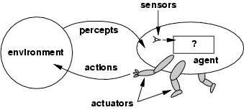
4. Generic agent - A general structure of an agent who interacts with the environment.

Fig : Agents interact with environments through sensors and effectors (actuators)
The term percept is to refer to the agent's perceptual inputs at any given instant.
PERCEPT SEQUENCE: Agent's percept sequence is the complete history of everything the agent has ever perceived.
An agent's behavior is described by the agent function that maps any given percept sequence to an action.
AGENT PROGRAM : The agent function for an artificial agent will be implemented by an agent program.
Example :
- The vacuum-cleaner world has just two locations: squares A and B.
- The vacuum agent perceives which square it is in and whether there is dirt in the square.
- It can choose to move left, move right, suck up the dirt, or do nothing.
- One very simple agent function is the following:
if the current square is dirty, then suck, otherwise move to the other square.
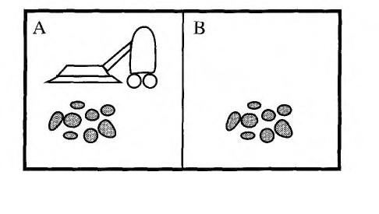

Fig : A vacuum-cleaner world with just two locations
Partial tabulation of a simple agent function for the vacuum-cleaner world
• Percepts: location and status, e.g., [A,Dirty]
• Actions: Left, Right, Suck, NoOp

Percept  sequence | Action
[A, Clean] | Right
[A, Dirty] | Suck
[B, Clean] | Left
[B, Dirty] | Suck

function VACUUM-AGENT([location,status])
if status = Dirty then return Suck
else if location = A then return Right
else if location = B then return Left

Concept of Rationality
- A rational agent is one that does the right thing.
- The right action is the one that will cause the agent to be most successful.
Performance measures
- A performance measure embodies the criterion for success of an agent's behavior.
- When an agent is plunked down in an environment, it generates a sequence of actions according to the percepts it receives.
Rationality
Rational at any given time depends on four things:
1. The performance measure that defines the criterion of success.
2. The agent's prior knowledge of the environment.
3. The actions that the agent can perform.
4. The agent's percept sequence to date.
Definition of a rational agent:
“For each possible percept sequence, a rational agent should select an action that is expected to maximize its performance measure, given the evidence provided by the percept sequence and whatever built-in knowledge the agent has.”
A rational agent should be autonomous
Definition of an omniscient agent:
An omniscient agent knows the actual outcome of its actions and can act accordingly; but omniscience is impossible in reality.
Autonomy
A rational agent should be autonomous-it should learn what it can to compensate for partial or incorrect prior knowledge.
Information Gathering
Doing actions in order to modify future percepts is called as information gathering.
Specifying the task environment
- the rationality of any agent, we had to specify the performance measure, the environment, and the agent's actuators and sensors.
- we call this as PEAS (Performance, Environment, Actuators, Sensors) or PAGE (Percept, Action, Goal, Environment) description.
- In designing an agent, the first step must always be to specify the task environment.
- Task environment is the “problems” to which rational agents are the “solutions”.
Example : PEAS description of the task environment for agents
Agent Type | Performance  Measure | Environment | Actuators | Sensors
Automated  Taxi Driver | Safe, fast, legal,  comfortable  trip,  maximize  profits | Roads,  traffic,  pedestrian  customers | Steering  accelerator,  brake,  signal,  horn,  display | Cameras, sonar,  speedometer,  GPS, odometer,  accelerometer  engine sensors,  keyboard
Medical  diagnosis  system | Healthy patient,  minimize costs,  lawsuits | Patient,  hospital, staff | Screen  display  (question  tests,  diagnoses  treatment  referrals) | Keyboard (entry  of symptoms,  findings, patient's  answers)
Part-Picking  Robot | Percentage of  parts in correct  bin | Conveyor belt  with parts,  bins | Jointed arm  and hand | Camera, joint  angle sensors
Interactive  English tutor | Maximize  student’s score  on test | Set of students | Screen  display  (exercises) | Keyboard
robot soccer  player | amount of goals  scored | soccer match  field | legs | cameras, sonar or  infrared
Satellite  Image  Analysis | Correct Image  Categorization | Downlink  from satellite | Display  categorizati  on of scene | Color pixel arrays
Refinery  controller | Maximum  purity, safety, yield | Refinery  operators | Valves,  pumps,  heaters, displays | Temperature,  pressure, chemical  sensors
Vacuum  Agent | minimize  energy  consumption,  maximize dirt  pick up | two squares | Left, Right,  Suck, NoOp | Sensors to identify  the dirt

Properties of task environments (Environment Types)
- Fully observable vs. partially observable:
- If an agent accesses the environment in all aspects using sensors to perform a action then the environment is accessible by the agent.
- If the sensors are not active or the environment changes every second then the environment is inaccessible.
- Deterministic vs. non – deterministic (or) Stochastic:
`If the next state of the environment is completely determined by the current state and the actions selected by the agents, then the environment is deterministic.
Accessible ---- deterministic
Inaccessible ---- Non- deterministic
- Static vs. dynamic
If the environment can change while an agent is deliberating, then we say the environment is dynamic for that agent; otherwise, it is static. Taxi driving is clearly dynamic. Crossword puzzles are static.
- Episodic vs. Sequential
- If an episodic environment, the agent’s experience is divided into episodes.
- Each episode consists of its own projects and actions and it does not depends on the previous episode.
- Discrete vs. Continuous
- If the number of distinct percepts and actions is limited, the environment is discrete, otherwise it is continuous.
- Taxi driving is a continuous state and continuous-time problem. Chess game has a finite number of distinct states.
- Single agent vs. Multi agent
- The distinction between single-agent and multi agent environments may seem simple enough.
- An agent solving a crossword puzzle by itself is clearly in a single-agent environment,
- An agent playing chess is in a two-agent environment.
Examples of task environments and their characteristics
Task  Environment | Observable | Deterministic | Episodic | Static | Discrete | Agent
Crossword  puzzle | Fully | Deterministic | Sequential | Static | Discrete | Single
Chess with a  clock | Fully | Stochastic | Sequential | Semi | Discrete | Multi
Poker | Partially | Stochastic | Sequential | Static | Discrete | Multi
Backgammon | Fully | Stochastic | Sequential | Static | Discrete | Multi
Taxi driving | Partially | Stochastic | Sequential | Dynamic | Continuous | Multi
Medical  diagnosis | Partially | Stochastic | Sequential | Dynamic | Continuous | Single
Image-  analysis | Fully | Deterministic | Episodic | Semi | Continuous | Single
Part-picking robot | Partially | Stochastic | Episodic | Dynamic | Continuous | Single
Refinery  controller | Partially | Stochastic | Sequential | Dynamic | Continuous | Single
Interactive  English tutor | Partially | Stochastic | Sequential | Dynamic | Discrete | Multi

• The simplest environment is - Fully observable, deterministic, episodic, static, discrete and single-agent.
• Most real situations are - Partially observable, stochastic, sequential, dynamic, continuous and multi-agent.

Problem solving Agents
- Problem solving agent is one kind of goal based agent, where the agent decides what to do by finding sequence of actions that lead to desirable states.
- The complexity arises here is the knowledge about the formulation process, (from current state to outcome action) of the agent.
- If the agent understood the definition of problem, it is relatively straight forward
to construct a search process for finding solutions.
- It implies that problem solving agent should be an intelligent agent to maximize the performance measure.
The sequence of steps done by the intelligent agent to maximize the performance
measure:
i) Goal formulation - based on current situation is the first step in problem solving. Actions that result to a failure case can be rejected without further consideration.
(ii)Problem formulation - is the process of deciding what actions and states to consider and follows goal formulation.

function SIMPLE-PROBLEM-SOLVING-AGENT(p)returns an action
input : p, a percept
static: s, an action sequence, initially empty
state, some description of the current world state
g, a goal initially null
problem, a problem formulation state <- UPDATE-STATE(state, p)
if s is empty then
g <- FORMULATE-GOAL(state)
problem <-FORMULATE-PROBLEM(state,g)
s <- SEARCH(problem)
action <- RECOMMENDATION(s, state)
s <- REMAINDER(s, state)
return action

(iii) Search - is the process of finding different possible sequence of actions that lead to state of known value, and choosing the best one from the states.
(iv) Solution - a search algorithm takes a problem as input and returns a solution in the form of action sequence.
(v) Execution phase - if the solution exists, the action it recommends can be carried out.
A simple problem solving agent
Note :
RECOMMENDATION - first action in the sequence
REMAINDER - returns the rest
SEARCH - choosing the best one from the sequence of actions
FORMULATE-PROBLEM - sequence of actions and states that lead to goal state.
UPDATE-STATE - initial state is forced to next state to reach the goal state.

Well-defined problems and solutions
A problem is really a collection of information that the agent will use to decide what to do.
A problem can be defined formally by four components:
1. initial state
2. successor function
3. goal test
4. path cost
The initial state - the agent knows itself to be start in.
Successor function (S) - Given a particular state x, S(x) returns a set of states reachable from x by any single action.
- The goal test - Single state description to check whether the goal state is reached or not.
- If more than one goal state exists, then we can check whether any one of the goal state is reached or not.

A path cost function that assigns a numeric cost to each path.
- Then problem-solving agent chooses a cost function that reflects its own performance measure.
D | AD
- The sum of the cost of the individual action along the path.
A solution to a problem is a path from the initial state to a goal state
Operator - The set of possible actions available to the agent.
State space (or) state set space - The set of all possible states reachable from the initial state by any sequence of actions.
Path (state space) - The sequence of action leading from one state to another.
The effectiveness of a search can be measured using three factors. They are:
1 Solution is identified or not?
2. Is it a good solution? If yes, then path cost to be minimum.
3.Search cost of the problem that is associated with time and memory required to find a solution.
Toy Problems
i) Vacuum world Problem
States: The agent is in one of two locations, each of which might or might not contain dirt. Thus there are 2 * 2² = 8 possible world states.
Initial state: Any state can be designated as the initial state.
Successor function: three actions (Left, Right, and Suck).
Goal test: This checks whether all the squares are clean.
Path cost: Each step costs 1, so the path cost is the number of steps in the path.
The 8 possible states of the simplified vacuum world problem.

AD | D

AD
AD

A | D

D | A
A
A

ii)8-puzzle Problem:
- The 8-puzzle problem consists of a 3 x 3 board with eight numbered tiles and a blank space.
- A tile adjacent to the blank space can slide into the space.
- The object is to reach a specified goal state
States: A state description specifies the location of each of the eight tiles and the blank in one of the nine squares.

Initial state: Any state can be designated as the initial state.

Successor function: This generates the legal states that result from trying the four actions (blank moves Left, Right, Up, or Down).

Goal test: This checks whether the state matches the goal configuration (Other goal configurations are possible.)

Path cost: Each step costs 1, so the path cost is the number of steps in the path.

Initial State Goal State

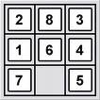
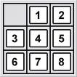

Water Jug Problem
- Given two jugs, a 4-gallon one and a 3-gallon one.
- Neither have any measuring markers on it.
- There is a pump that can be used to fill the jugs with water.
- How can you get exactly 2 gallons of water into the 4-gallon jug?
States: The state space for this problem can be described as the set of ordered pairs of integers(x,y) such that x=0,1,2,3, or 4 and y=0,1,2, or 3:x represents the number of gallons of water in the 4-gallon jug, and y represents the quantity of the water in the 3-gallon jug.
Initial state: The starting state is (0, 0) where 3 –gallon jug and 4- gallon jug are empty
Successor function: This generates the legal productions that result from trying the 12 actions (empty the jug, Pour some water from jug, Fill the jug).
1. (x, y) if x<4 -> (4 , y)
2. (x, y) if y<3 ->(x , 3)
3. (x, y) if x>0 ->(x-d , y)
4. (x, y) if y>0 ->(x ,y-d)
5. (x, y) if x>0 ->(0 , y)
6. (x, y) if y>0 ->(x, 0)
7. (x, y) if x+y>=4 and y>0 -> (4 , y-(4-x))
8. (x, y) if x+y>=3 and x>0 ->(x-(3-y), 3)
9. (x, y) if x+y<=4 and y>0 ->(x+y, 0)
10. (x, y) if x+y<=3 and x>0 -> (0, x+y)
11. (0, 2) -> (2, 0)
12. (2, y) -> (0, y)
Goal test: The goal state is (2, n) for any value of n (the problem does not specify how many gallons need to be in the 3-gallon jug)
Path cost: Each step costs 1, so the path cost is the number of steps in the path.
Gallons in the 4- Gallon Jug | Gallon in the 3- Gallon Jug | Rule Applied
0 | 0 | 2
0 | 3 | 9
3 | 0 | 2
3 | 3 | 7
4 | 2 | 5 or 12
0 | 2 | 9 or 11
2 | 0
INDEXING:
When knowledgebase is too large to be held in main memory, it must be stored as a file in secondary storage. Storage and retrieval of information in secondary memory is then performed through the transfer of equal size physical blocks.
Time required to transfer a block is same as the time required to sequentially search the whole block. Grouping together rules which share some of the same conditions and conclusions reduce block transfer times.
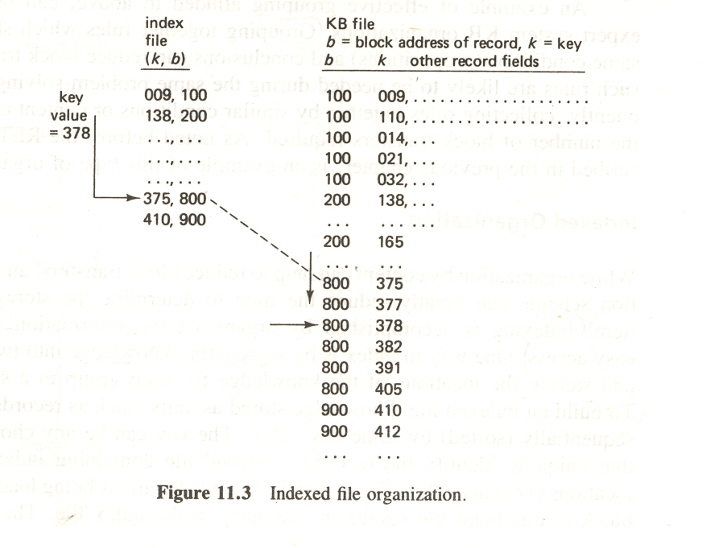
- An indexed organization scheme can reduce the time to determine the storage location of an item.
- Indexing is accomplished by organizing the information in some way for easy access.
- To build an indexed file, knowledge’s stored as units (such as records) are first arranged sequentially by some key value.
- The key can be any chosen field or fields that uniquely identify the record
- The key value is the key of the first record stored in the corresponding block. To retrieve an item of knowledge from the main file, the index files searched to fine the desired record key and obtain the corresponding block address.
- An indexed file contains a list of the entry pairs (k,b)where the values k are the keys of the first record in each block whose starting address is b.Figure 11.3 illustrates the process used to locate a record using the key value of 378.The largest key value less than 378(375)gives the block address(800)where the item will be found. Once the 800 block has been retrieved, it can be searched linearly to locate with key value 378.
Hashed Files:
Indexed Organizations that permit efficient accesses are based on the use of a hash function. A hash function, h, transforms key values k into integer storage location indices through a simple computation. When a maximum number of items or categories C are to be stored, the hashed values h(k) will range from 0 to C-1.Therefore ,given any key valuek,h(k)should map into one of 0…C-1
.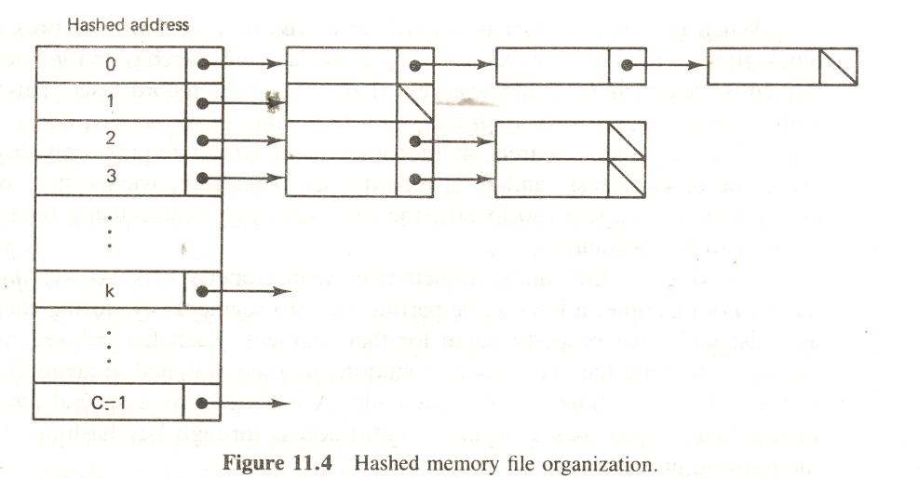
This type of organization is well suited for groups of items corresponding to C different categories. When two or more items belong to the same category, they will have the same hashed values. These values are called synonyms.
Conceptual Hashing:
- Keys for conceptual hashing are typically chosen as a coded field (employee number, name, part number, and so on) which uniquely identifies the item.
- A better approach to indexed retrieval is one which makes use of the content or meaning associated with the stored entities rather than some no meaningful key value.
- This suggests the use of indices which name and define or otherwise describe the entity being retrieved .Thus, if the entity is an object ,its name and characteristic attributes would make meaningful indices.
- Nodes within the network correspond to different knowledge entities, whereas the links are indices or pointers to the entities. Links connecting two entities name the association or relationship between them.
- Objects may be classified with an unlimited number of attributes (color, size, shape, markings, and so on), those attributes which are most discriminable with respect to the concept meaning should be chosen.
- A good index for bird types is one based on individual differences like feet, size, beak shape, sound emitted, special markings, and so forth.
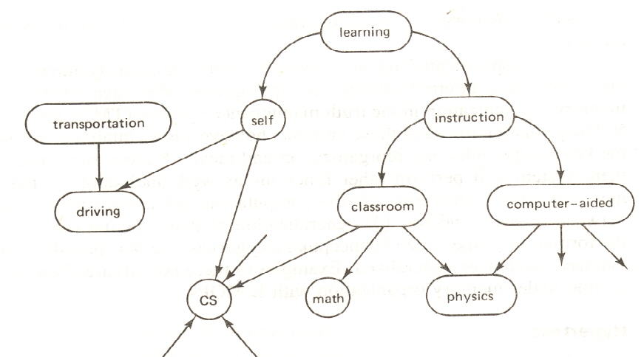

Blind Search (or) Uninformed Search Strategies
BREADTH-FIRST SEARCH:
1.Definition: Breadth-first search is a simple strategy in which the root node is expanded first, then all the successors of the root node are expanded next, then their successors, and so on.
• In general, all the nodes are expanded at a given depth in the search tree before any nodes at the next level are expanded.
• Breadth-first search can be implemented by calling TREE-SEARCH with an empty fringe that is a first-in-first-out (FIFO) queue, assuring that the nodes that are visited first will be expanded first.
• In other words, calling TREE-SEARCH(Problem, FIFO-QUEUE())results in a breadth-first search.
• The FIFO queue puts all newly generated successors at the
end of the queue, which means that shallow nodes are expanded before deeper
nodes.
2. Breadth first search trees after node expansions

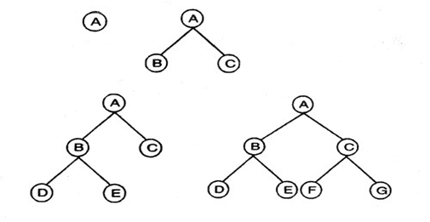
Example: Route finding problem

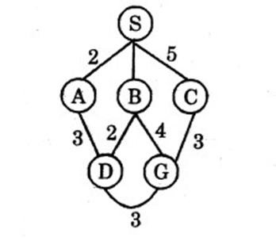

Task: Find a ,path from. S to G using BFS

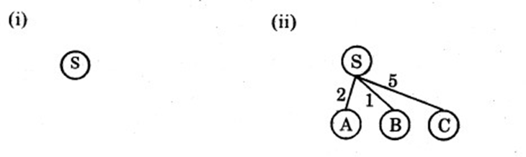

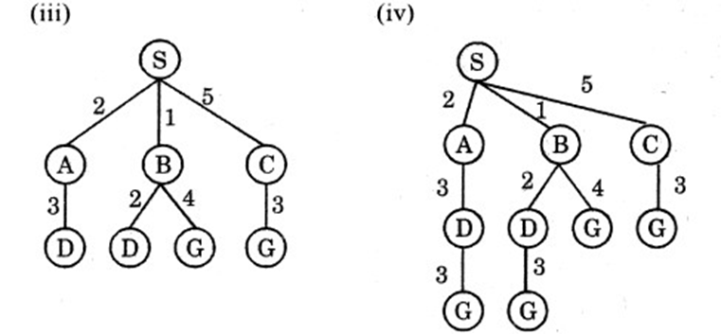

The path in the 2nd depth level is selected, (i.e) SBG{or) SCG.
3. Algorithm :
function BFS{problem) returns a solution or failure
return TREE-SEARCH (problem, FIFO-QUEUE( ))
4.Time and space complexity:
Example:
Time complexity
= 1 +b + b^ 2 + + b ^d
=O(b^d)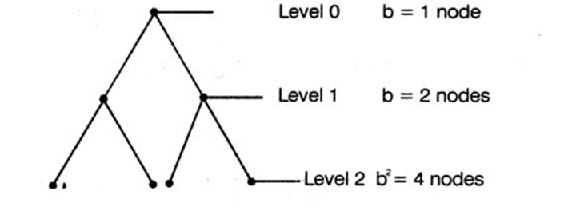

The space complexity is same as time complexity because all the leaf nodes of the tree must be maintained in memory at the same time = O(b d)

5. Completeness: Yes

6. Optimality: Yes, provided the path cost is a non decreasing function of the depth of the node

7. Advantage: Guaranteed to find the single solution at the shallowest depth level

8. Disadvantage: Suitable for only smallest instances problem (i.e.) (number of
levels to be minimum (or) branching factor to be minimum)

Local Search Algorithms And Optimization Problems:
In many optimization problems, the path to the goal is irrelevant; the goal state itself is the solution.
The best state is identified from the objective function or heuristic cost function. In such cases, we can use local search algorithms (ie) keep only a single current state, try to improve it instead of the whole search space explored so far.
For example, in the 8-queens problem, what matters is the final configuration of queens, not the order in which they are added.
Local search algorithms operate a single current state (rather than multiple paths) and generally move only to neighbours of that state. Typically, the paths followed by the search are not retained.
They have two key advantages:

(1) They use very little memory-usually a constant amount; (2) They can often find reasonable solutions in large or infinite (continuous) state spaces for which systematic algorithms are unsuitable.

The local search problem is explained with the state space land scape. A landscape has:

Location - defined by the state

Elevation - defined by the value of the heuristic cost function or objective function, if elevation corresponds to cost then the lowest valley (global minimum) is achieved. If elevation corresponds to an objective function, then the highest peak (global maximum) is achieved.
A complete local search algorithm always finds a goal if one exists, an optimal algorithm always finds a global minimum/maximum.
A one-dimensional state space landscape in which elevation corresponds to the objective function.
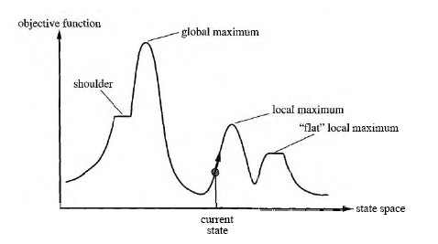
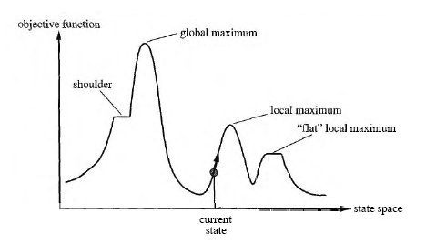
Applications
Integrated - circuit design
Factory - floor layout
Job-shop scheduling
Automatic programming
Vehicle routing
Telecommunications network Optimization
Advantages
- Constant search space. It is suitable for online and offline search
- The search cost is less when compare to informed search.
- Reasonable solutions are derived in large or continuous state space for which systematic algorithms are unsuitable.
Some of the local search algorithms are:

1. Hill climbing search (Greedy Local Search)
2. Simulated annealing
3. Local beam search
4. Genetic Algorithm (GA)

HILL CLIMBING SEARCH (GREEDY LOCAL SEARCH)
- The hill-climbing search algorithm is simply a loop that continually moves in the direction of increasing value.
- It terminates when it reaches a "peak" where no neighbor has a higher value.
- The algorithm does not maintain a search tree, so the current node data structure need only record the state and its objective function value.
- At each step the current node is replaced by the best neighbor;

Hill-climbing search algorithm
function HILL-CLIMBING(problem) returns a state that is a local maximum
inputs: problem, a problem
local variables:current, a node and neighbor, a node
current <- MAKE-NODE(INITIAL-STATE[problem])
loop do
neighbor <- a highest-valued successor of current
if VALUE[neighbor] <= VALUE[current] then return STATE[current]
current <- neighbor

To illustrate hill-climbing, we will use the 8-queens, where each state has 8 queens on the board, one per column. The successor function returns all possible states generated by moving a single queen to another square in the same column (so each state has 8 x 7 = 56 successors).
Hill-climbing algorithms typically choose randomly among the set of best successors, if there is more than one.

The heuristic cost function h is the number of pairs of queens that are attacking each other, either directly or indirectly.
The global minimum of this function is zero, which occurs only at perfect solutions.
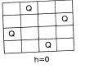
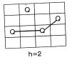

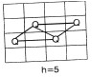

An 8-queens state with heuristic cost estimate h = 17, showing the value of h for each possible successor obtained by moving a queen within its column. The best moves are marked.
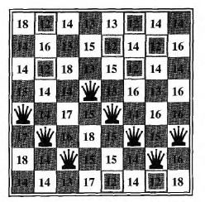
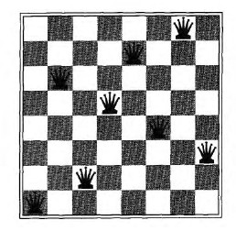

A local minimum in the 8-queens state space; the state has h = 1 but every successor has a higher cost.
Hill climbing often gets stuck for the following reasons:

Local maxima or foot hills : a local maximum is a peak that is higher than each of its neighboring states, but lower than the global maximum
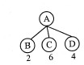
Example :

The evaluation function value is maximum at C and from their there is no path exist for expansion. Therefore C is called as local maxima. To avoid this state, random node is selected using back tracking to the previous node.
Plateau or shoulder: a plateau is an area of the state space landscape where the evaluation function is flat. It can be a flat local maximum.

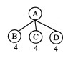
Example :

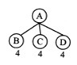
The evaluation function value of B C D are same, this is a state space of plateau. To avoid these state, random nodes is selected or skip the level (i.e) select the node in the next level
Ridges: Ridges result in a sequence of local maxima that is very difficult for greedy algorithms to navigate. But the disadvantage is more calculations to be done that correspond to moving in several directions at once.

Structure of hill climbing drawbacks

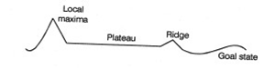

Variants of hill-climbing

Stochastic hill climbing - Stochastic hill climbing chooses at random from among the uphill moves; the probability of selection can vary with the steepness of the uphill move.

First-choice hill climbing - First-choice hill climbing implements stochastic hill climbing by generating successors randomly until one is generated that is better than the current state
Random-restart hill climbing - Random-restart hill climbing adopts the well-known adage, "If at first you don't succeed, try, try again." It conducts a series of hill-climbing searches from randomly generated initial state, stopping when a goal is found.

CONSTRAINT SATISFACTION PROBLEMS (CSP)
Constraint satisfaction problems (CSP) are mathematical problems where one must find states or objects that satisfy a number of constraints or criteria.
A constraint is a restriction of the feasible solutions in an optimization problem.
Some examples for CSP's are:
1. Then-queens problem
2. A crossword puzzle
3. A map coloring problem
4. The Boolean satisfiability problem
5. A crypt arithmetic problem

All these examples and other real life problems like time table scheduling, transport scheduling, floor planning etc. are instances of the same pattern,

A Constraint Satisfaction Problem (or CSP) is defined by a set of variables
{X1,X2,….Xn,} and a set of constraints {C1,C2,…,Cm}. Each variable Xi has a nonempty domain D, of possible values.
Each constraint Ci involves some subset of variables and specifies the allowable combinations of values for that subset.
A State of the problem is defined by an assignment of values to some or all of the variables,{Xi = vi, Xj = vj,…}.
An assignment that does not violate any constraints is called a consistent or legal assignment.
A complete assignment is one in which every variable is mentioned, and a solution to a CSP is a complete assignment that satisfies all the constraints. Some CSPs also require a solution that maximizes an objective function.
Example for Constraint Satisfaction Problem :
The map coloring problem. The task of coloring each region red, green or blue in such a way that no neighbouring regions have the same color.
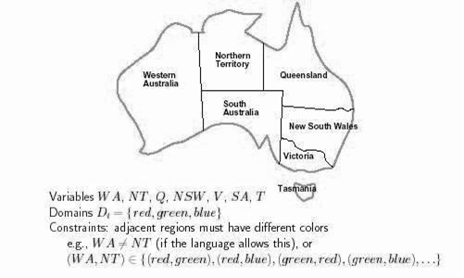
Map of Australia showing each of its states and territories

We are given the task of coloring each region red, green, or blue in such a way that the neighbouring regions must not have the same color.
To formulate this as CSP, we define the variable to be the regions: WA, NT, Q, NSW, V, SA, and T.
The domain of each variable is the set {red, green, blue}.
The constraints require neighbouring regions to have distinct colors: for example, the allowable combinations for WA and NT are the pairs{(red,green),(red,blue),(green,red),(green,blue),(blue,red),(blue,green)}. (The constraint can also be represented as the inequality WA ≠ NT)
There are many possible solutions, such as
{WA = red, NT = green, Q = red, NSW = green, V = red, SA = blue,T = red}.
Constraint Graph: A CSP is usually represented as an undirected graph, called constraint graph where the nodes are the variables and the edges are the binary constraints.
The map-coloring problem represented as a constraint graph.
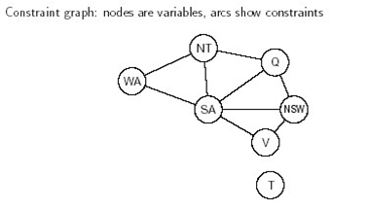

CSP can be viewed as a standard search problem as follows:
• Initial state: the empty assignment {}, in which all variables are unassigned.
• Successor function: a value can be assigned to any unassigned variable provided that it does not conflict with previously assigned variables.
• Goal test: the current assignment is complete.
• Path cost: a constant cost (E.g., 1) for every step.
• Every solution must be a complete assignment and therefore appears at depth n
if there are n variables. So Depth first search algorithms are popular for CSPs.
Backtracking Search for CSPs
The term backtracking search is used for depth-first search that chooses values for one variable at a time and backtracks when a variable has no legal values left to assign.

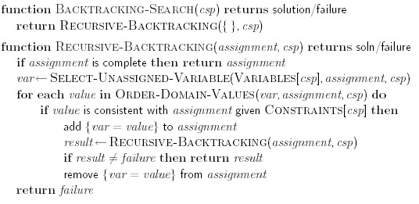

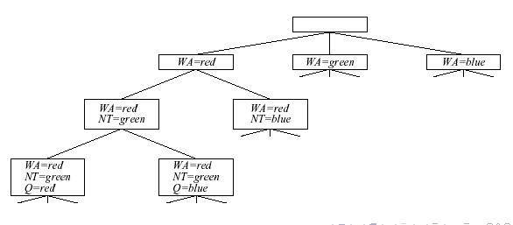

Part of search tree generated by simple backtracking for the map coloring problem

